
RAMAIAH
Institute of Technology
USN | 1 | M | S

(Autonomous Institute, Affiliated to VTU)
(Approved by AICTE, New Delhi & Govt. of Karnataka) Accredited by NBA & NAAC with ‘A’ Grade

SUPPLEMENTARY SEMESTER EXAMINATIONS – AUGUST 2019

Course & Branch | : | B.E. : Electrical and Electronics Engineering | Semester | : | VI
Subject | : | Power Systems – I | Max. Marks | : | 100
Subject Code | : | EE61 | Duration | : | 3 Hrs

Instructions to the Candidates:
- Answer one full question from each unit.

 |  | UNIT- I
1. | a) | Explain the per unit representation of power system components. | CO2 | (08)
 | b) | Explain short circuit currents and the reactances of synchronous machines. A generator is rated 500MVA, 20kV, with sub-transient reactance of 20%. It supplies a purely resistive load of 400MW at 20kV. The load is connected directly across the terminals of the generator. If all 3 phases of the load are short-circuited simultaneously find the initial symmetrical current in the generator in per unit on a base of 500MVA, 20kV. | CO1 | (12)
2. | a) | A synchronous generator and motor rated 30MVA, 13.2kV and both have sub-transient reactance of 20%. The line connecting them has a reactance of 10% on the base of the machine ratings. The motor is drawing 20MWat 0.8 pf leading. The terminal voltage of the motor is 12.8kV. When a symmetrical 3 phase fault occurs at the motor terminals at P, find the sub-transient current in generator, motor and at the fault point. The equivalent circuit is shown in Fig. 2(a). Choose generator ratings as the base.  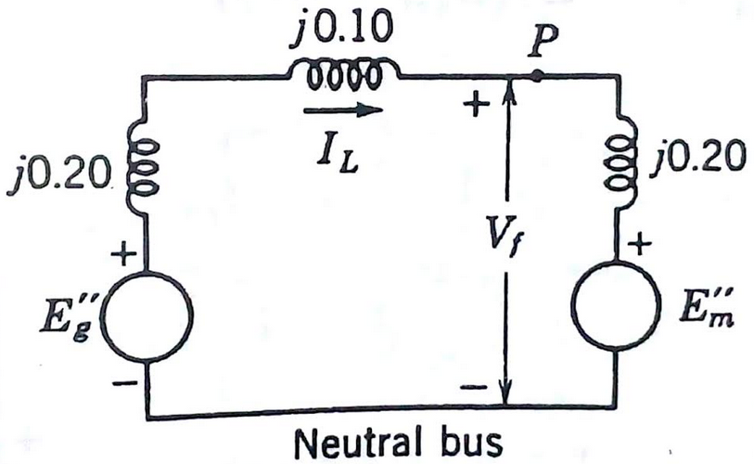  Fig.2 (a) | CO3 | (12)
 | b) | A 120MVA, 19.5kV, generator has Xs= 1.5pu and is connected to a transmission line by a transformer rated 150MVA, 230Y/18ΔkV with X=0.1pu. If the base to be used in the calculation is 100MVA, 230kV, for the transmission line, find the per unit values to be used for the transformer and generator reactances. | CO1 | (08)
 |  | UNIT- II
3. | a) | Prove that a balanced three phase system of voltage phasor contains only positive sequence components. | CO4 | (08)
 | b) | The currents flowing in the lines towards a balanced load connected in delta are I_{a} =100∟0⁰, I_{b}=141.4∟225⁰, I_{c} =100∟90⁰ A. Start by drawing phasor diagrams of of the positive and negative sequence line and phase currents and find the symmetrical components of the given line currents. Find I_{ab}in Amperes from the symmetrical components of the given line currents. | CO4 | (12)
4. | a) | In a 3 phase 4 wire system the sequence voltages and currents are V_{a1} =0.9∟10⁰, V_{a2} =0.25∟110⁰, V_{a0} =0.12∟300⁰, I_{a1}=0.75∟25⁰, I_{a2}=0.15∟170⁰, I_{a0}=0.1∟330⁰all in pu. Find the complex power in pu. If the neutral gets disconnected find the new power. | CO4 | (10)
 | b) | Discuss the phase shifts of sequence components of voltages in the primary and secondary windings of a star-delta transformer with the help of phasor diagrams. | CO1 | (10)
 |  | UNIT- III
5. | a) | A star connected synchronous generator has sequence reactances X₀=0.09, X₁=0.22, X₂=0.36 all in pu. The neutral point of the machine is grounded through a reactance of 0.09 pu. The machine is running on no load with rated terminal voltage when it suffers an unbalanced fault. The fault currents out of the machine are I_{a}=0, I_{b}=3.75∟150⁰, and I_{c}=3.75∟30⁰, all in pu with respect to phase ‘a’ line to neutral voltage. Determine i) the terminal voltages in each phase of the machine with respect to ground ii) the voltage of the neutral point of the machine with respect to ground and iii) the fault type . | CO4 | (10)
 | b) | Explain the sequence networks of:  i) unloaded generators ii) transmission lines. | CO4 | (10)
6. | a) | Determine the negative and zero sequence networks for the system shown in Fig. 6(a). Mark all the values of reactance on a base of 50MVA, 13.8kV in the circuit of generator1. The neutrals of generators 1 and 3 are connected to ground through current limiting reactors having a reactance of 5% each on the base of the machine to which it is connected. Each generator has negative and zero sequence reactance of 20% and 5% respectively on its own rating as base. The zero sequence reactance of the transmission line is 210Ω from B to C and 250Ω from C to E.  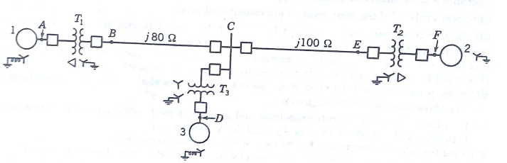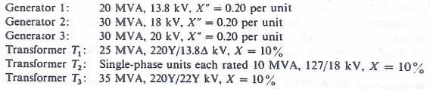  Fig. 6(a) | CO4 | (12)
 | b) | Obtain the sequence networks of an unloaded three phase star connected generator grounded through a reactor. | CO4 | (08)
 |  | UNIT- IV
7. | a) | A double line to ground fault occurs at the terminals of a loaded generator. Derive an expression for the fault currents. Draw the connection of sequence networks. | CO4 | (10)
 | b) | A three phase, 11kV, 10MVA alternator has sequence reactance of X₀=0.05pu, X₁=0.15pu, X₂=0.15pu. If the generator is on no load, find the ratio of fault currents for LG fault to that when all the three phases are short circuited. | CO4 | (10)
8. | a) | What are the different types of unsymmetrical faults and explain in brief their frequency of occurrence? | CO4 | (08)
 | b) | A three phase generator with line to line voltages of 400V is subjected to an LLG fault. If Z₁=j2Ω, Z₂=j0.5Ω, and Z₀=j0.25Ω. Determine the fault current. | CO4 | (08)
 | c) | Discuss open conductor fault in power system. | CO4 | (04)
 |  | UNIT- V
9. | a) | What is ‘equal area criterion’? Explain the application of equal area criterion for the system stability study when sudden change in mechanical input takes place. | CO5 | (10)
 | b) | A 50Hz, 4pole turbo alternator rated 100MVA, 11 kV, has an inertia constant of 8.5 MJ/MVA. Find the  - The rotor acceleration if the input mechanical power is raised to 120 MW when the electrical load is 80MW  - The speed at the end of 20 cycles if the acceleration is assumed constant at the initial value. | CO5 | (05)
 | c) | For a salient pole synchronous machine, neglecting the effect of armature resistance, derive an expression for power developed as a function of load angle. | CO5 | (05)
10. | a) | A 50Hz, synchronous generator having inertia constant of 5.2MJ/MVA and x_{d}ˊ = 0.3 pu is connected to an infinite bus through a double circuit line. The reactance of the connecting HT transformer is 0.2 p.u and the reactance of each line is 0.4 p.u. |E_{g}| = 1.2 pu , |V|= 1.0 pu and P_{e} = 0.8pu. Determine the critical clearing angle and the post fault steady state operating angle in the following cases:  i) Three phase fault occurs at the HT terminals of the transformer and is cleared with both lines intact.  ii) Three phase fault occurs at the middle of one of the transmission lines and is cleared without line outage. | CO5 | (10)
 | b) | Arrive at the swing equation of a synchronous machine connected to infinite bus system. Draw the typical swing curve and mention its uses. | CO5 | (10)

****************

